ANALYSIS -SID/JAISON/PERPLEXITY
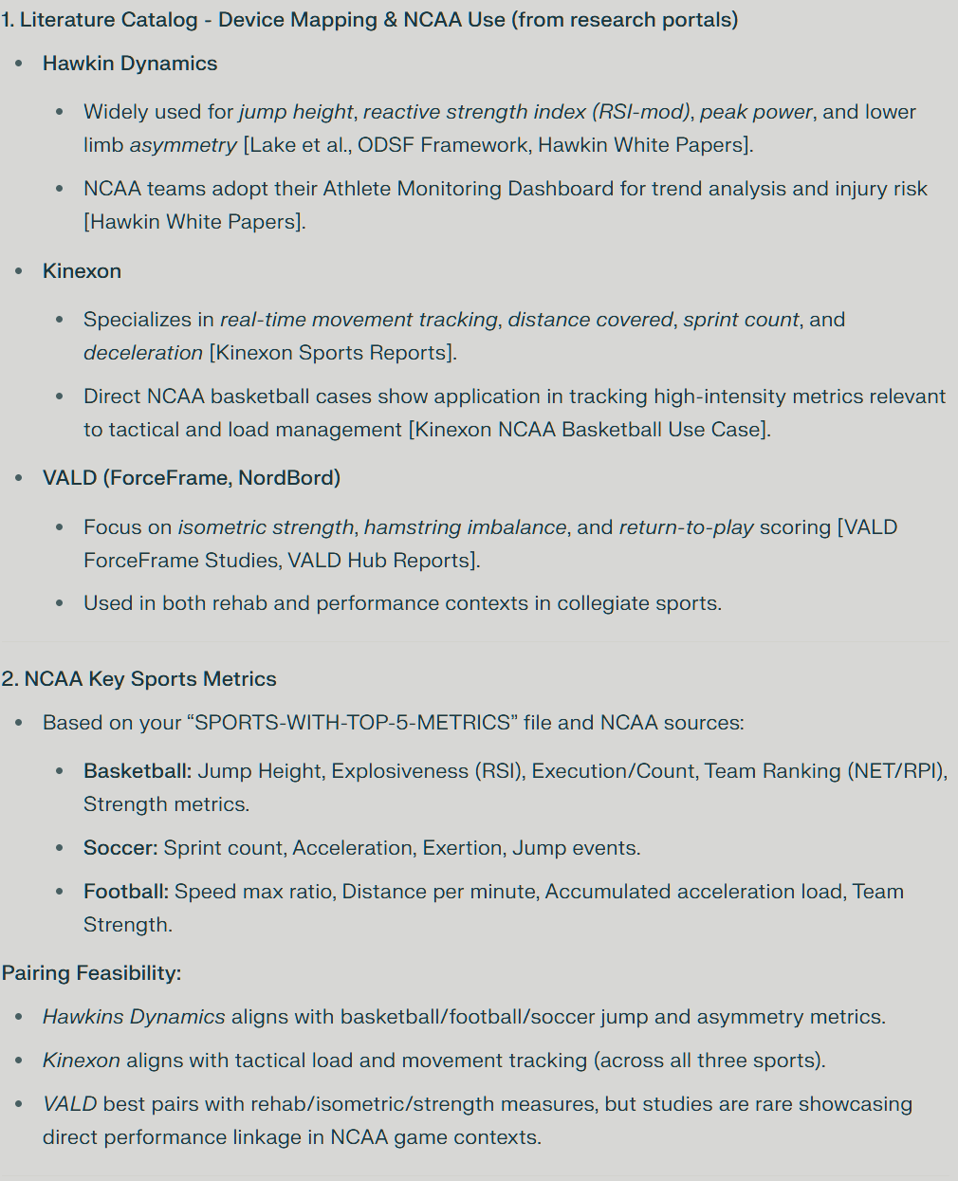
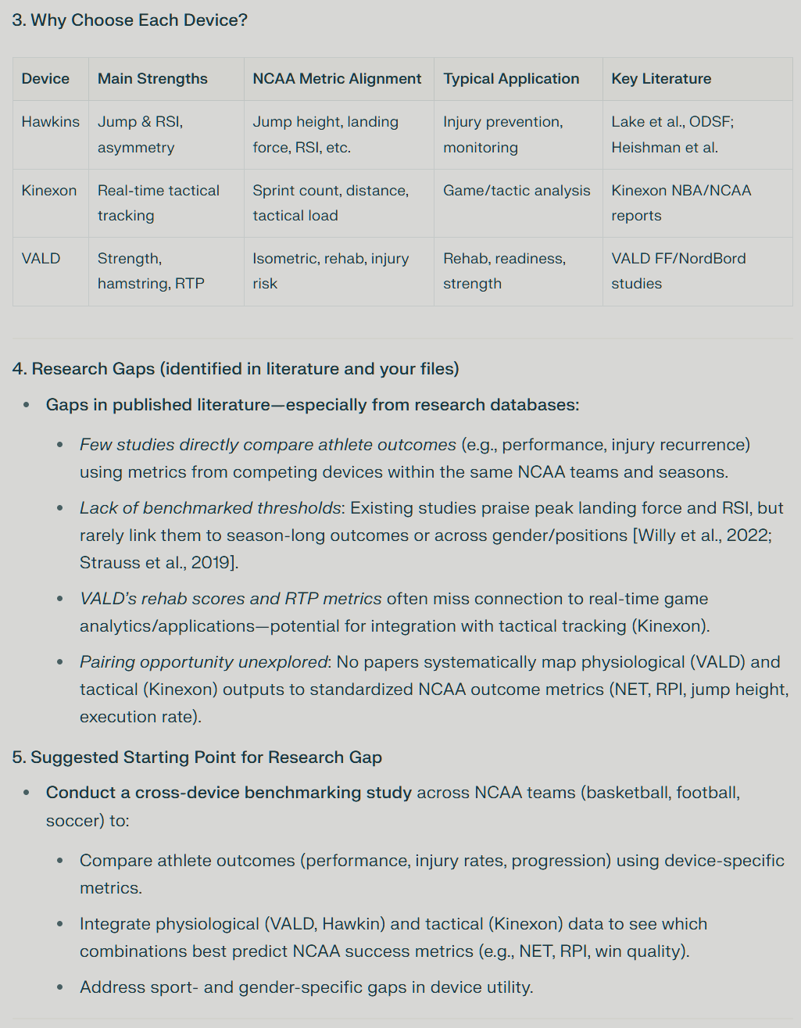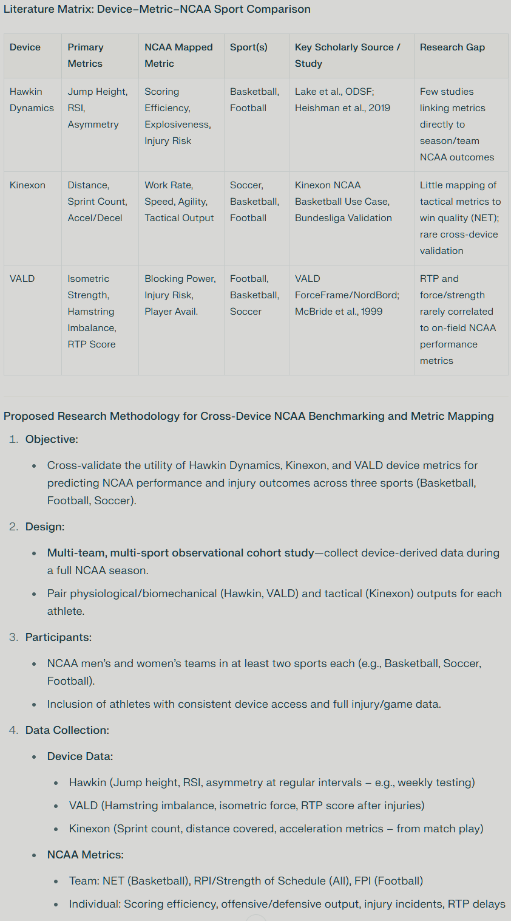

Based on the full synthesis of your files , the OCR-extracted tables, and mapped research and NCAA priorities, the top 5 metrics you should use—and that can be verified across basketball, football, and soccer ( if our data set supports it)
